1. **Total Loan Applications:** We need to calculate the total number of loan applications received during a specified period. Additionally, it is essential to monitor the Month-to-Date (MTD) Loan Applications and track changes Month-over-Month (MoM).

**Total Applicant:**

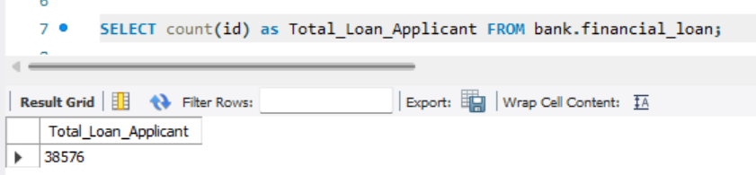

**Month-to-Date (MTD) Loan Applications:**

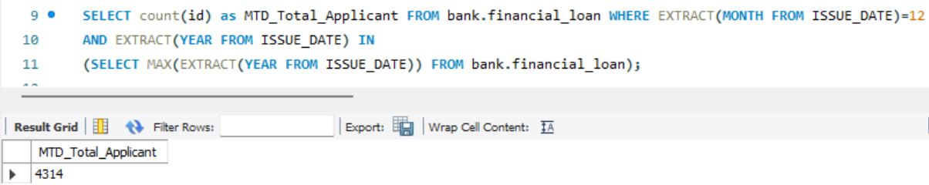

**Month-over-Month (MoM) Loan Applications:**

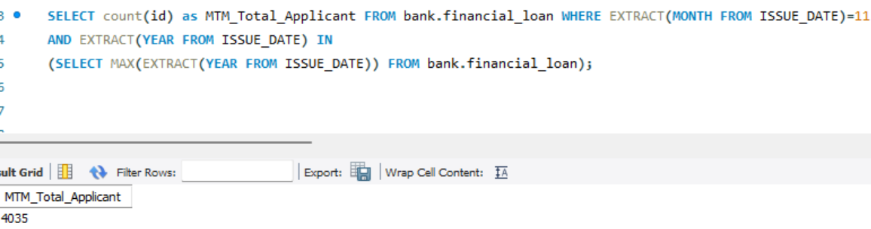

1. **Total Funded Amount:** Understanding the total amount of funds disbursed as loans is crucial. We also want to keep an eye on the MTD Total Funded Amount and analyse the Month-over-Month (MoM) changes in this metric

**Total Funded Amount:**

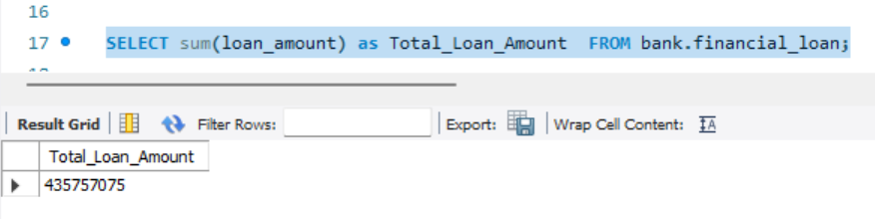

**MTD Total Funded Amount:**

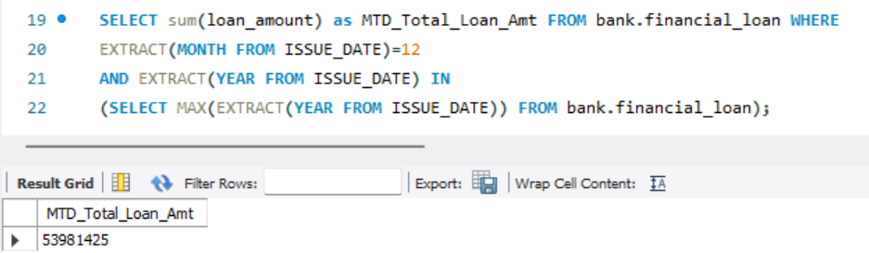

**MTM Total Funded Amount:**

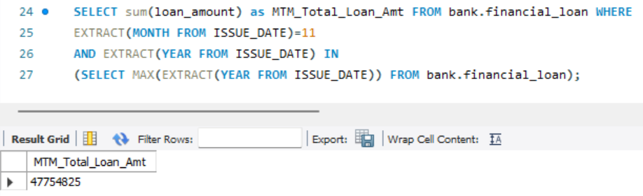

1. **Total Amount Received:** Tracking the total amount received from borrowers is essential for assessing the bank's cash flow and loan repayment. We should analyse the Month-to-Date (MTD) Total Amount Received and observe the Month-over-Month (MoM) changes

**Total Amount Received:**

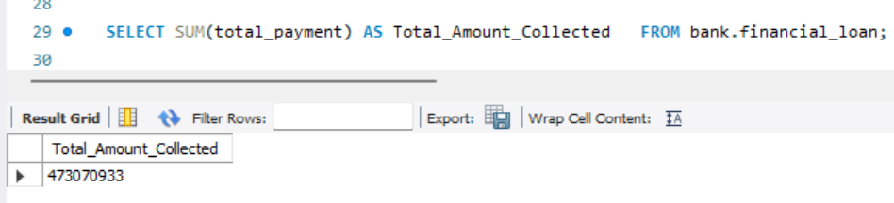

**MTD Total Amount Received:**

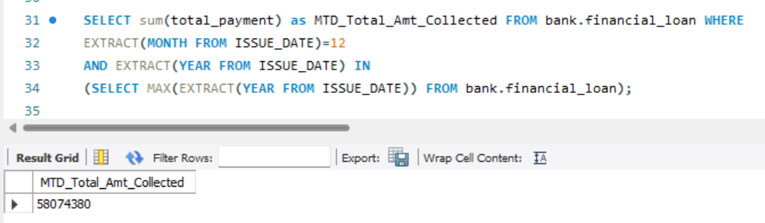

**MTM Total Amount Received:**

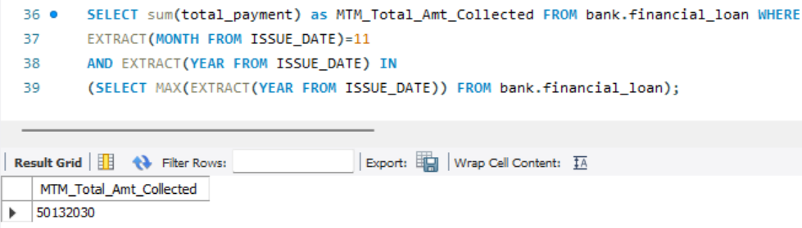

1. **Average Interest Rate:** Calculating the average interest rate across all loans, MTD, and monitoring the Month-over-Month (MoM) variations in interest rates will provide insights into our lending portfolio's overall cost

**Average Interest Rate:**

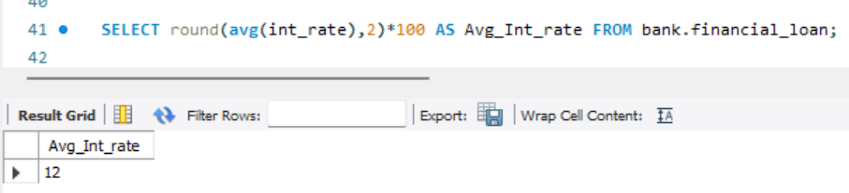

**MTD Average Interest Rate:**

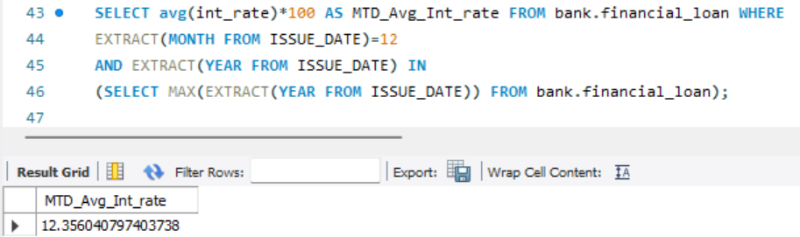

**MTM Average Interest Rate:**

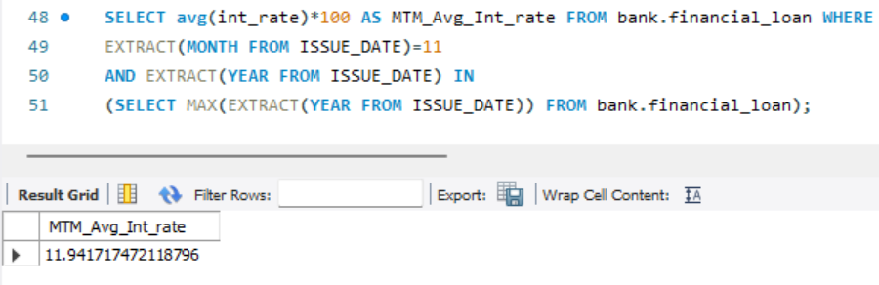

1. **Average Debt-to-Income Ratio (DTI):** Evaluating the average DTI for our borrowers helps us gauge their financial health. We need to compute the average DTI for all loans, MTD, and track Month-over-Month (MoM) fluctuations.

**Average Debt-to-Income Ratio (DTI):**

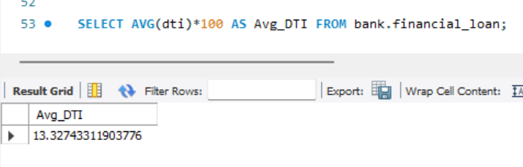

**MTD_ Average Debt-to-Income Ratio (DTI):**

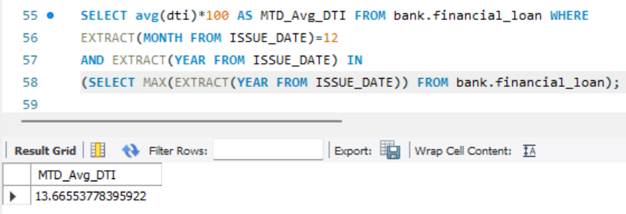

**MTM_ Average Debt-to-Income Ratio (DTI):**

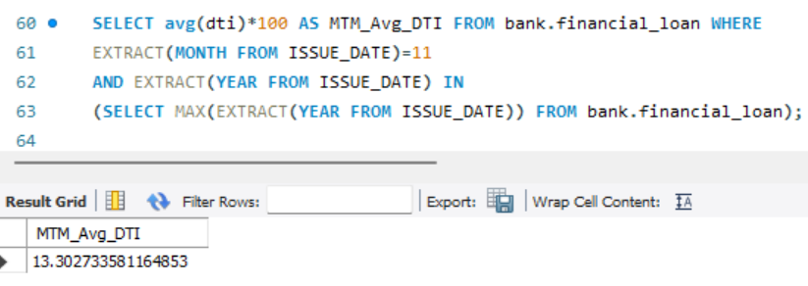

**Good Loan Application Percentage:**

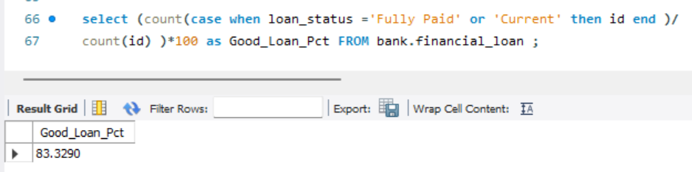

**Good Loan Application:**

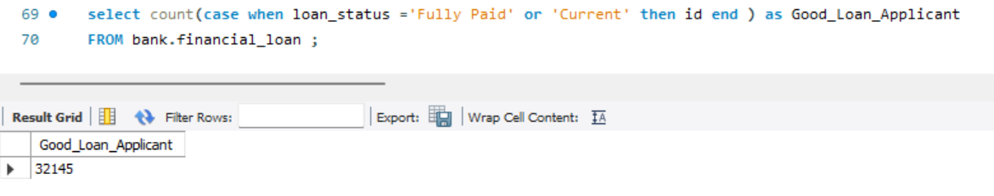

**Good Loan Funded Amount:**

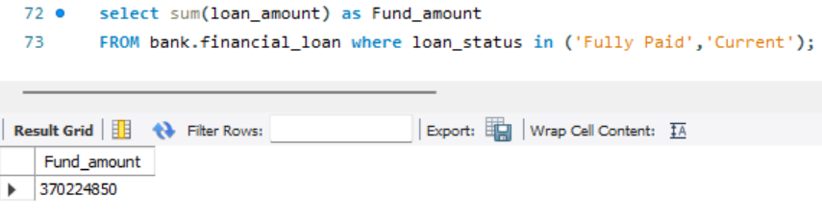

**Good Loan Total Received Amount:**

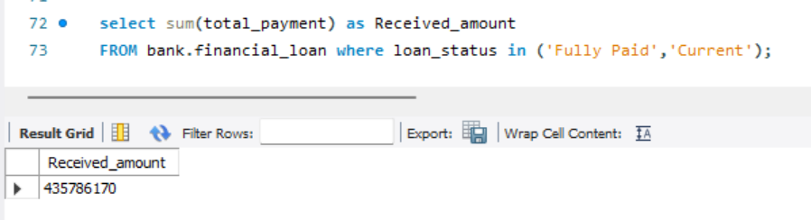

**Bad Loan Application Percentage:**

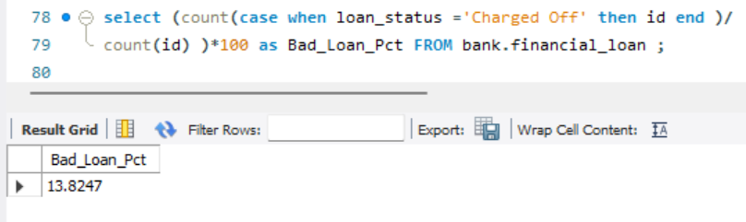

**Bad Loan Applications:**

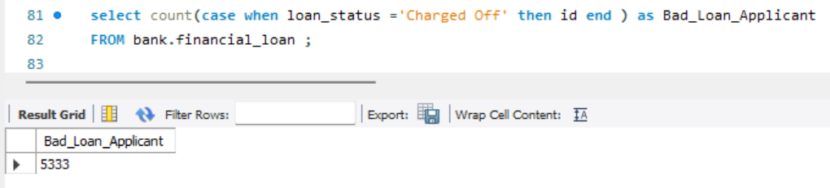

**Bad Loan Funded Amount:**

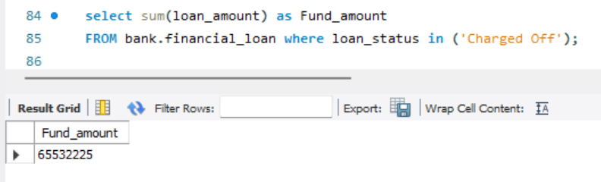

**Bad Loan Total Received Amount:**

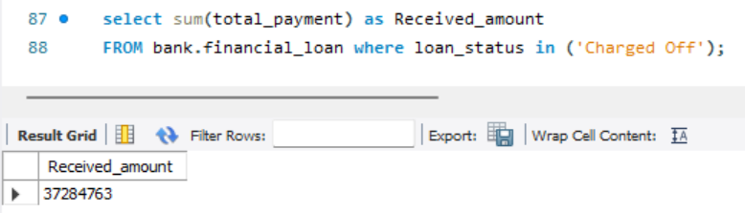

**comprehensive overview:**

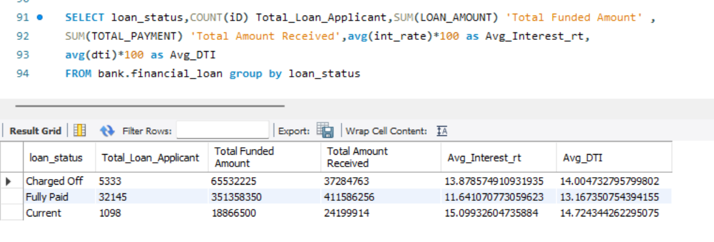

**Bank Loan Report:**

